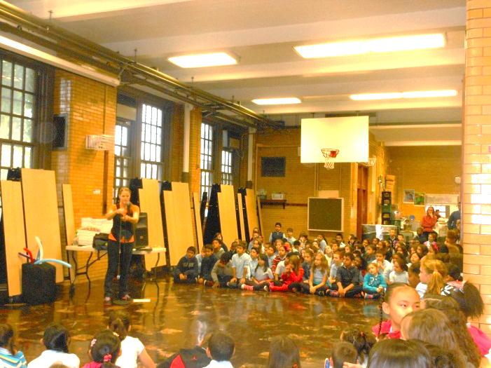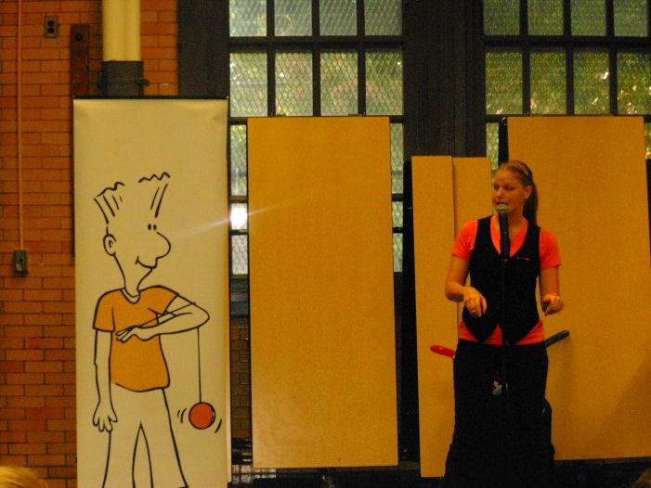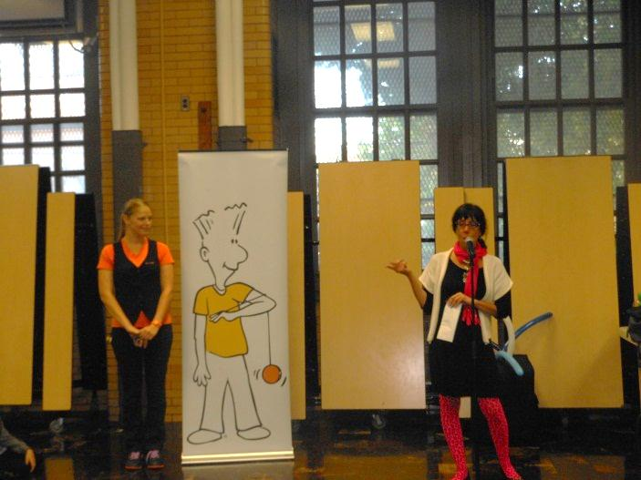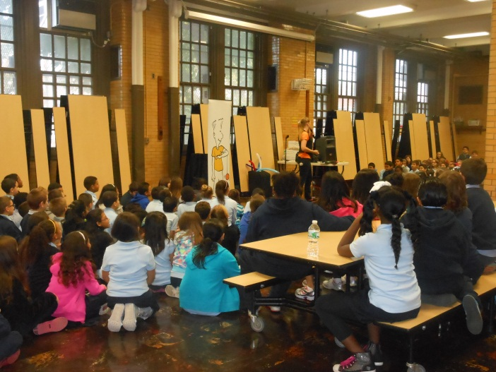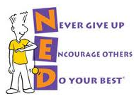

The NED Show combines a positive message with humor, storytelling, audience participation and memorable object lessons like yo-yo and magic tricks. The assembly teaches students how they can develop three valuable characteristics to become CHAMPIONS at school and in life…

See a brief video about this dynamic 45-minute assembly and see what all the excitement is about by visiting <www.theNEDshow.com>!

The lovable character NED, and his message, are an inspiration for all ages. We look forward to the lasting, positive impact it will have at our school.